Input data file having invalid and valid records.

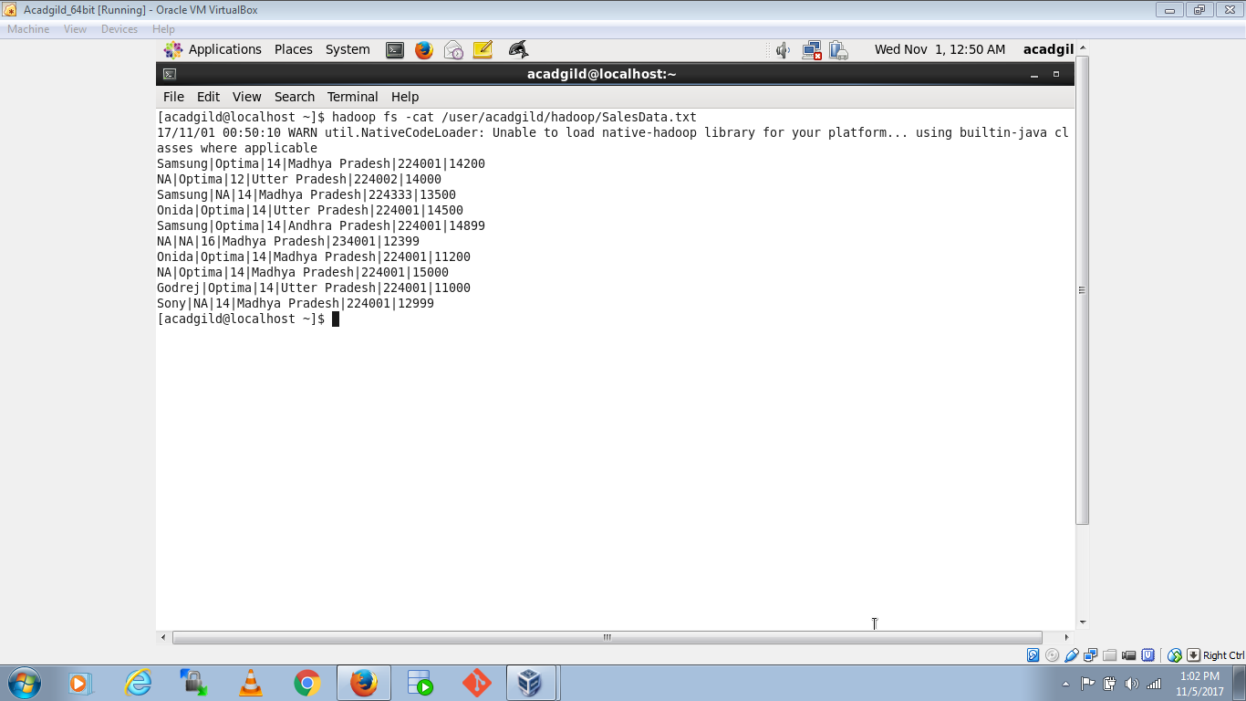

Running first MapReduce task as given in assignment:

“Write a Map Reduce program to calculate the total units sold for each Company.”

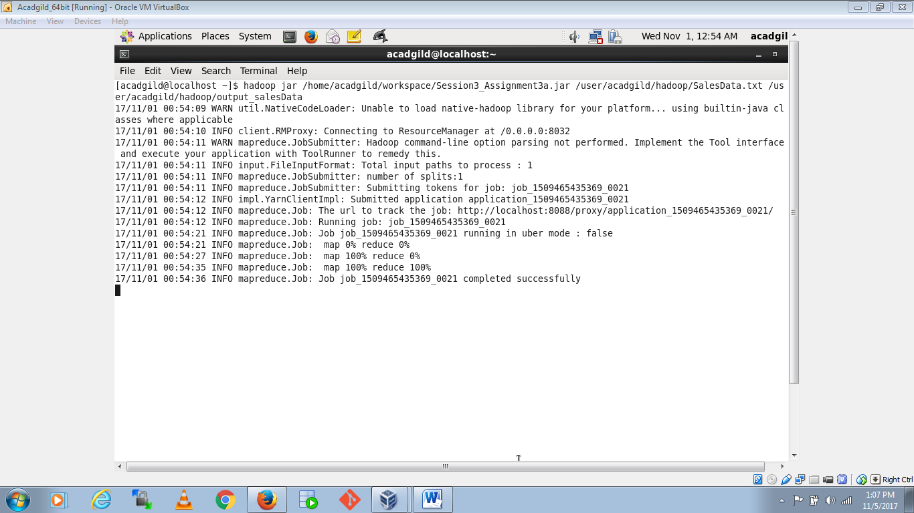

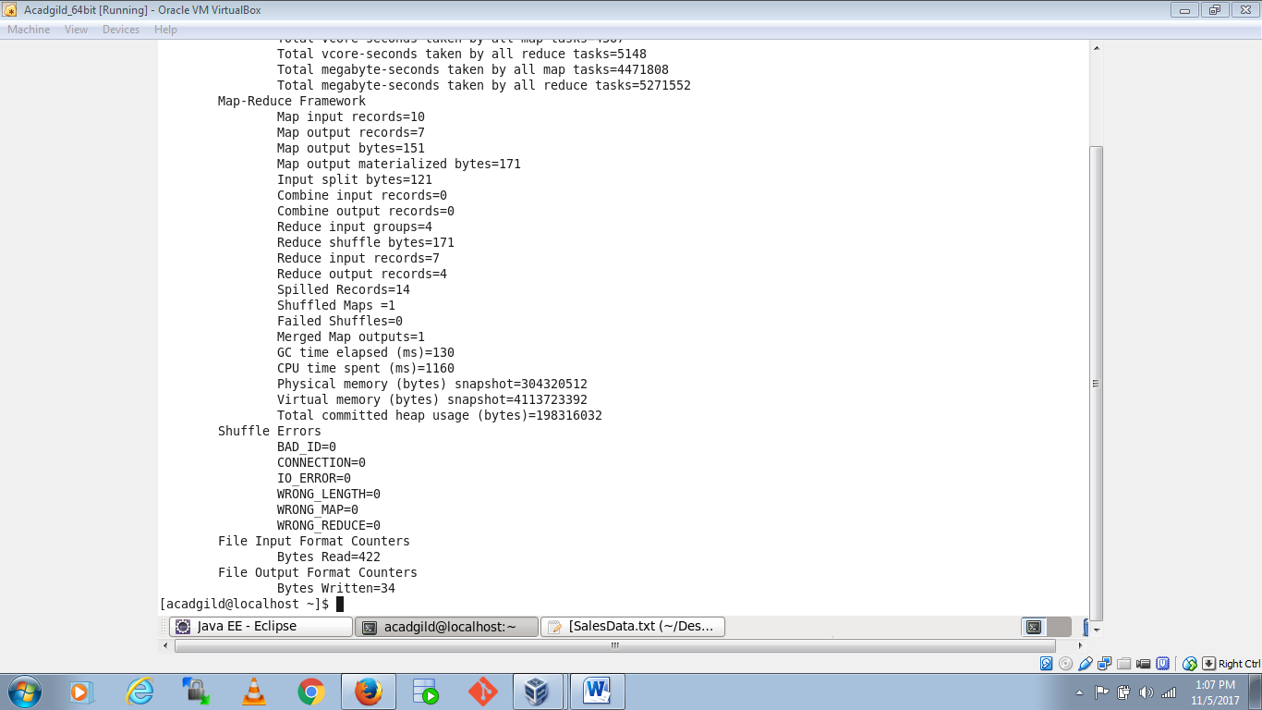

Output:

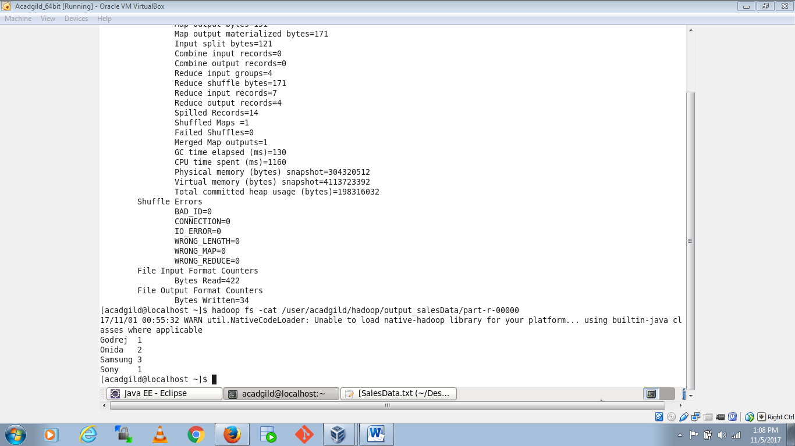

Running Second MapReduce task as given in assignment:

“Write a Map Reduce program to calculate the total units sold in each state for Onida company.”

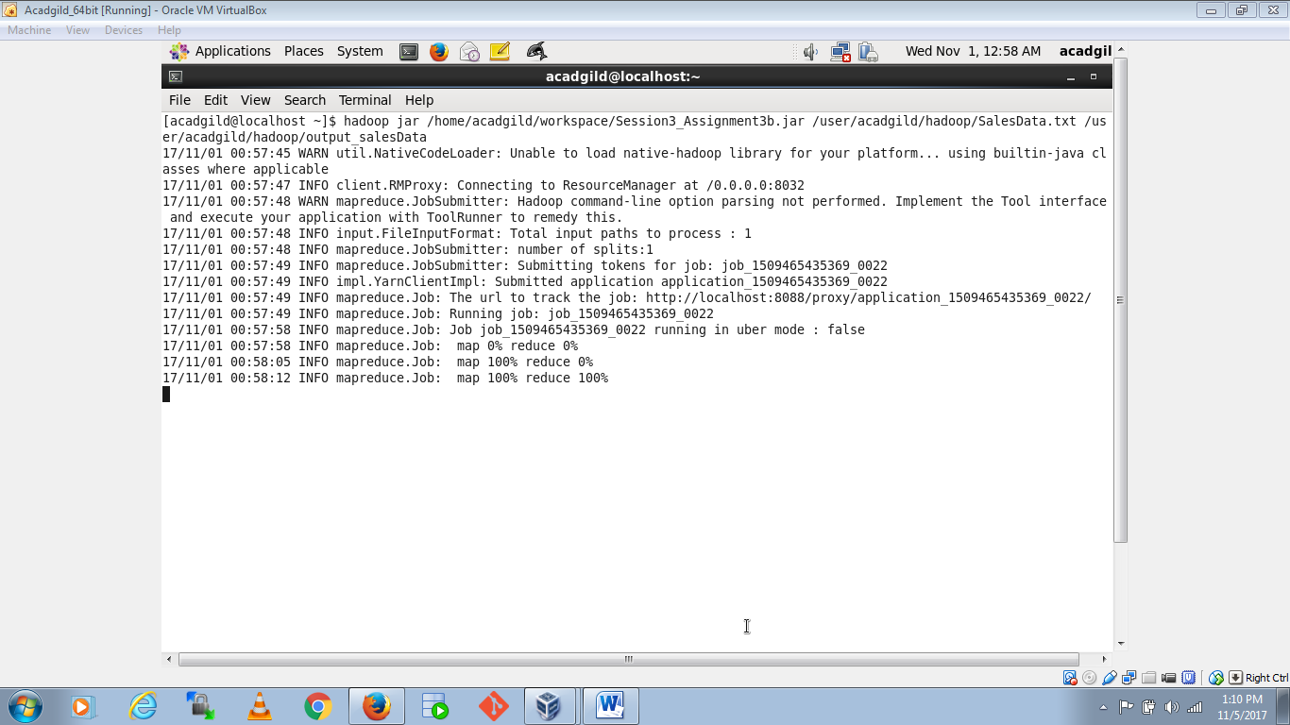

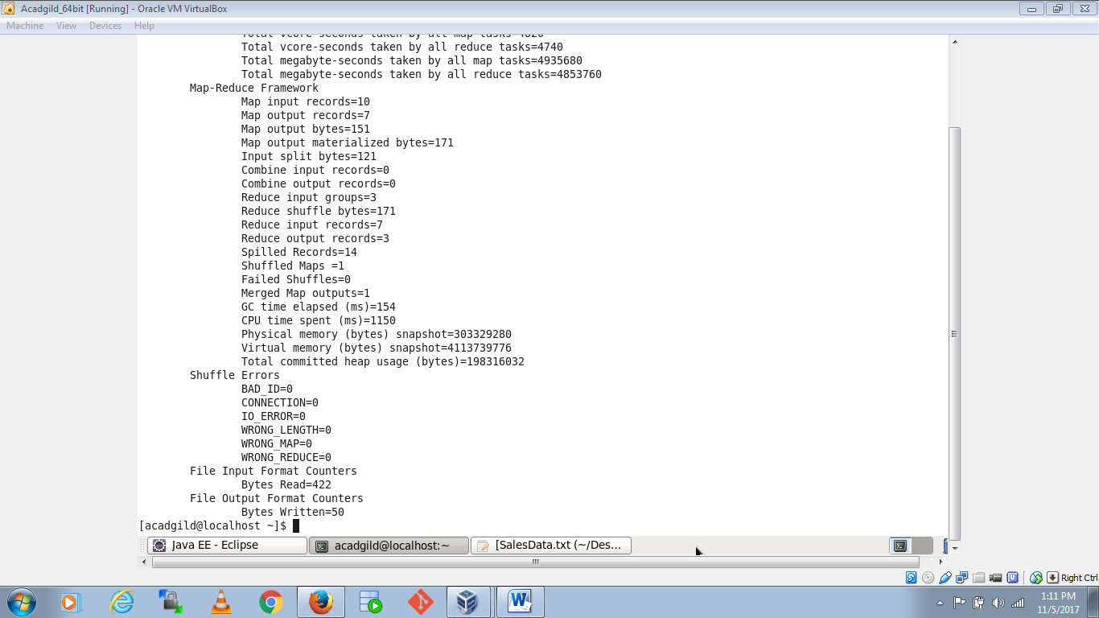

Output:

